25-08-2026

Experiment 17: Write a Python Program to Implement Feed Forward Neural Network for Classification Using Scikit-learn

Aim
To write and execute a Python program to implement a Feed Forward Neural Network (FFNN) for classification.

Algorithm
- Import the required Python libraries.
- Create the input dataset and target values.
- Split the dataset into training and testing data.
- Create a Feed Forward Neural Network using an MLP classifier.
- Train the neural network using the training dataset.
- Predict the output for the testing dataset.
- Calculate the accuracy of the neural network.
- Display the predicted output and accuracy.

Program
from sklearn.neural_network import MLPClassifier
from sklearn.metrics import accuracy_score

# Input data
X = [
[0, 0],
[0, 1],
[1, 0],
[1, 1]
]

# Target output
y = [0, 1, 1, 0]

# Create Feed Forward Neural Network
model = MLPClassifier(
hidden_layer_sizes=(4,),
activation='relu',
solver='lbfgs',
max_iter=1000,
random_state=42
)

# Train the model
model.fit(X, y)

# Predict output
y_pred = model.predict(X)

# Display results
print("Input Data:")
print(X)

print("\nActual Output:")
print(y)

print("\nPredicted Output:")
print(y_pred)

# Calculate accuracy
accuracy = accuracy_score(y, y_pred)

print("\nAccuracy:", accuracy * 100, "%")

Output

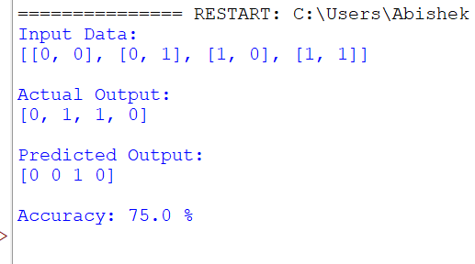

Result
Thus, the Feed Forward Neural Network was successfully implemented in Python and correctly classified the given input data.

